# Executive Summary

Matt Rock – DS710 Final

Live sports and Twitter are a perfect combination. As exciting as the last-second scores and defensive stands are to witness, the feeling that you are part of a community of people screaming “DID YOU SEE THAT?” all to the same unbelievable play from all over is special. Can we graph that fan interest via tweets and retweets during a game?

Sunday, December 1st, the 2-9 New York Giants hosted the 8-3 Green Bay Packers at the Meadowlands. The Giants have replaced Eli Manning, who has won two Super Bowls, with Daniel Jones, their first-round rookie out of non-football power Duke. Comparatively, 2 time MVP Aaron Rodgers has the Packers leading their division and in position for a first-round bye. Suffice to say, two large fanbases that have recently had success have different enthusiasm about this matchup.

I used Twitter’s REST API to compile any tweet and retweet that mentions the official Twitter handles and hashtags for both teams - @Giants, #GiantsPride, @Packers, #GoPackGo, as well as the neutral #GBvsNYG game hashtag. My timeframe was from 11 AM to 4 PM on December 1st. I then categorized each tweet by if they mentioned the Giants, Packers, and either the neutral hashtag or both teams. This is a chart of the total count of each type during the time frame.

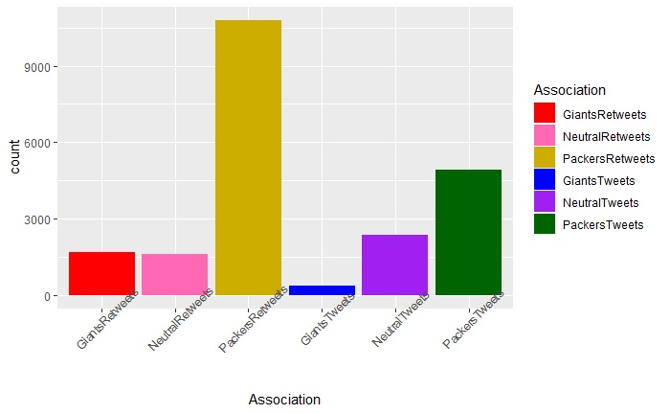

The playoff-bound Packers clearly had the most active fanbase during the game. What interested me is that the number of tweets and retweets was statistically significantly different. I found more retweets than tweets in my timeframe, but more neutral tweets than neutral retweets. I’d take that as a strong indication that neutral fans don’t have the same community. They aren’t actively following the Packers or Giants accounts or other fans of that team, so their own ‘community’ isn’t the NFL, it’s their own team.

Additionally, while Packers fans had a lot to cheer about in their 31-13 victory, and dominated both tweets and retweets, Giants fans still retweeted quite a bit during the game. They may not signal that they’re supporting the team as actively, but they can click the retweet button when something they like happens.